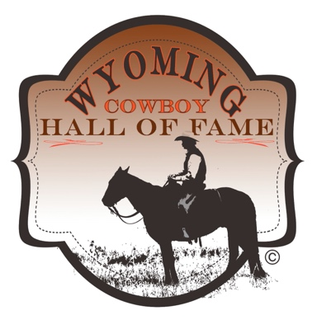

Frequently Asked Questions

Q. Can anyone submit a nomination?
A. Yes, anyone can submit a nomination. Our hope, our goal is to make the most of the wealth of local knowledge across the state about our significant Cowboy culture.

Q. How do I submit an application for a nominee?
A. Nomination applications will be available on the Wyoming Cowboy Hall of Fame website from October 1 through February 15, of each year. Download the word document to your computer, fill in the nomination form completely while saving your work frequently, then attach your completed nomination form to an email to wchfassistant@gmail.com with the Nominee’s name and county in the subject line of the email. Also attach 1-10 photos in jpg or tiff formats, NO PDF photos. (Photos may be submitted as single file but be sure to include the county and nominee name in the subject line.)

Q. Is there any fee to submit an application for a nominee?
A. No, but you can choose to make a donation, via PayPal, when you submit your application to help defer some of the costs involved with processing your nomination application and investigating your nominee.

Q. What happens to my application after I submit it?
A. Completed nominations will be sorted and sent to the regions/county in which the nominee resided in most of their cowboy/cowgirl life. Regional Committees will meet and review the nominations of potential honorees in their region in March. After investigating the nominations, the Regional Committees will identify nominees they wish to recognize and forward their recommendations to the WCHF Board to consider. The WCHF Board will review the recommendations and verify the nominees (in May) that will be inducted that year. The WCHF recognizes only statewide inductees; there are no additional regional inductees selected. The State induction will be held in October. Sometimes the induction coincides with Wyoming Cowboy and Cowgirl Legacy Week. In some cases, a local or regional program also may be held to celebrate the inductees.

Q. Do the Regional Committees and the WCHF Board only select 1 nominee to be inducted each year?
A. There may be one inductee from each county. Additionally, the WCHF Board may select additional inductees from an at-large pool of nominees recommended by the regional committees. There is an expectation of inducting one person from each county annually, however there is no requirement that a county have an inductee each year.

Q. If the person I nominate isn’t chosen as an inductee, do I need to submit another application the following year for them to be considered?
A. Yes, you do. You will not need to send all details (such as photos), but you will be required to provide an updated general application to ensure that we have accurate details.

Q. How will I know if the person I nominated was selected to be inducted?
A. The nominator of individuals selected for induction will be notified and all inductees to the Wyoming Cowboy Hall of Fame will be publicized state-wide.

Q. How can I help the Cowboy Hall of Fame?
A. There are several ways you can help the Cowboy Hall of Fame. First of all, you can go to the Support Page on the website and choose the level of support you’d like to send. Second, you can serve as a member of your regional committee, please contact Candy Moulton (WCHF Executive Director) if you are interested in doing so, wchfassistant@gmail.com

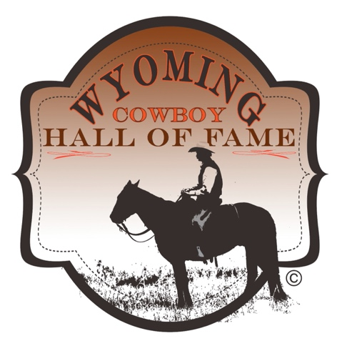

Wyoming Cowboy Hall of Fame Induction Nomination Form

The WCHF accepts nominations from October 1 to Feb. 15 for the 2024 Inductee Class

Qualifications:

- Cowboy means Cowgirl, too.
- Minimum age for living inductee is 65. Special circumstances can be considered.
- Inductees may be honored posthumously.
- Minimum time of 45 years working – for a livelihood – in the saddle. The predominant part of nominee’s work should have involved riding horseback and working livestock.
- Group nominations are allowed (Siblings: brothers & sisters; Spouses, Family). For group nominations ALL nominees must meet ALL requirements. The nomination form must include the basic information and responses to questions on the nomination form for ALL individuals. Also, the nomination story must include detail for EVERY individual in the nomination group. If any information is missing, the nomination will not be considered. No exceptions.
- Nominees do not need to have been born in Wyoming, but all nominees must have had primary residence in Wyoming and spent the majority of their time as a working cowboy in Wyoming. Any nominee who does meet this requirement will not be considered. No exceptions. (In the case of a group nomination, ALL individuals must meet this requirement.)
- Ownership of a ranch (or even land) is not a requirement. The nominee could have spent his/her working time as a ranch hand.
- Cowboy work is the primary criteria. Work in affiliated occupations is not a determining factor, i.e. rodeo contestant, veterinarian, livestock auctioneer, brand inspector, outfitter. Work in those occupations can be listed but must supplemental to the requirement for cowboy work.
- The Wyoming county the nominee spent the majority of their working life in is required so we know which county committee will review the nomination.
- Each nominator is responsible for the accuracy of the information in the application. Please double check your dates, provide EXACT spelling of names so we have that for award materials if your nominee is selected for induction. These items cannot be corrected after a certain date. If an application is found to have included erroneous information, the application will be disqualified.
- All information categories on the nomination form are required to include birth date, death date (if applicable), contact information for nominee, nominator, key family, and background information.
- At least one photograph must be submitted that clearly shows the nominee’s face. At least 2, or up to 10, additional photos should also be submitted that may show the nominee doing his/her cowboy job. All photos must be submitted as jpg files at 300 dpi resolution, suitable for publication. (This requirement for additional photos may be waived for posthumous nominations). All photos submitted will be used for public information to honor those individuals being inducted into WCHF. If you do not have permission from the photographer for publication/use of any photograph or piece of artwork, do not submit it as part of your application. Each photo submitted must have the name of the nominee in the file name. For example: John Doe Photo 1.jpg; John Doe Photo2.jpg

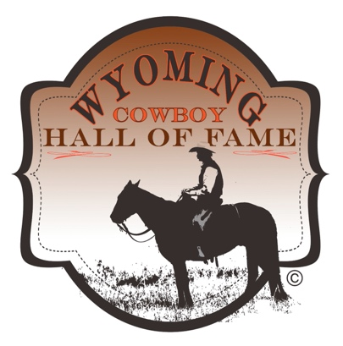

NOMINATION FORM 2024

Name of Nominee:
(be certain the name is listed EXACTLY the way it should go on any award if your nominee is selected for induction. If incorrect information is provided on the induction nomination, WCHF is NOT responsible for redoing any plaque, certificate, etc.)

Nickname, if any:
Phone (Best contact number for nominee):
Mailing Address of Inductee (for possible induction notification):
Date of Birth:
Date of Death (if applicable):
Hometown:
Wyoming County where nominee spent the majority of their working life:
Spouse name (if applicable):
Children (if applicable; include email addresses and phone numbers for all):
Number of years working as a cowboy in Wyoming:
(Point value for general background information: 15)

Is this a new nomination: Yes____. No____.
If you checked yes, please continue to fill out the sections below.

If you checked no, please indicate first year the application was submitted:
Year:_____
If you do not know the year, or if this is a new application, please continue filling out the remainder of this form.
If you have provided the year, and we can locate your original nomination, you do not need to fill out the remainder of this form and your prior nomination will be submitted to the appropriate committee for review. We will contact you if we do not locate the original nomination, to inform you what parts of the nomination we need resubmitted.
Nominee’s Story: (The WCHF would like you to share any of the following virtues to help us better understand what made the nominee a cowboy: How they made a living as a cowboy, time spent working horseback (working horseback, not rodeoing). Did they work cattle, sheep, or horses – could they doctor a sick animal, could they make a saddle, were they a good neighbor, what was their job at brandings, what character attributes do they have that make them a cowboy?)
This part of the nomination should be in two sections.
Section 1: A detailed story that includes these elements:
- A general biography of nominee that tells about his/her life as a working cowboy (describe with emphasis on work done while horseback).
- Number of years working as a cowboy, in the saddle, making a livelihood.
- Narrative about where the nominee did cowboy work both within and outside of Wyoming, type of work, and any other historical and biographical background relevant to cowboy work and skills that represent cowboy culture. This can include details about ranches where nominee worked and/or other skills that support, enhance, or promote cowboy work and lifestyle i.e. saddlemaking, art, music, writing, farrier, etc.

Section 2: Simple list of ranch(es) names and locations (state/county) where nominee worked (provide dates of employment as accurately as possible):

Section 2: Simple list of activities nominee was involved with that demonstrate service to community, the state, or the cowboy lifestyle. This could include membership on boards, work with youth such as 4-H, FFA, etc.

Nominator’s Information

Name:

Relationship to the Nominee:

Address:

City:

Wyoming County:

State:

Zip Code:

Email (Verify this is typed correctly as we will email you to let you know your nomination has been received and whether your nominee is selected for induction):

Phone (Best contact number for nominator):

Best Person to Contact About Nomination (if not the person making the nomination):

Thank you for nominating your favorite working cowboy or cowgirl!

Please verify that all of your work has been saved in the above form before attaching and sending in an email.

Don’t forget to send photos in jpg format, to the same email as the nomination form: wchfassistant@gmail.com.

If you have questions about this form, please contact Candy Moulton, WCHF Executive Director by email at wchfassistant@gmail.com.

